MP:

Đường dẫn:

Cài đặt:

/u01/mp

Log: /var/log/1M/mp

Binary:

/u01/mp/platforms/bin

Script: /u01/mp/script

Tiến trình MP:



Status MP:

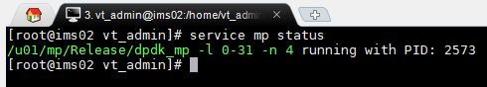

Htop MP:

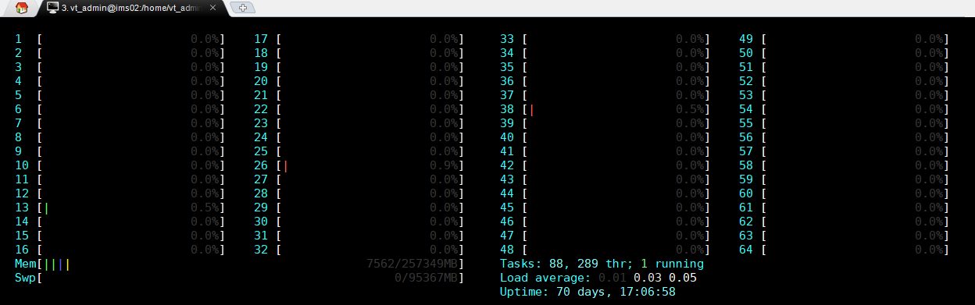

172.16.1.158:10000

Ping :

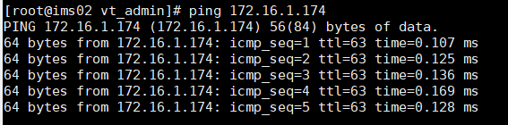

**STATUS:**

ENUM/DNS

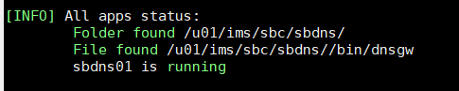

[INFO] All apps status:

Folder found /u01/ims/sbc/sbdns/

File found /u01/ims/sbc/sbdns//bin/dnsgw

sbdns01 is running

H.248:

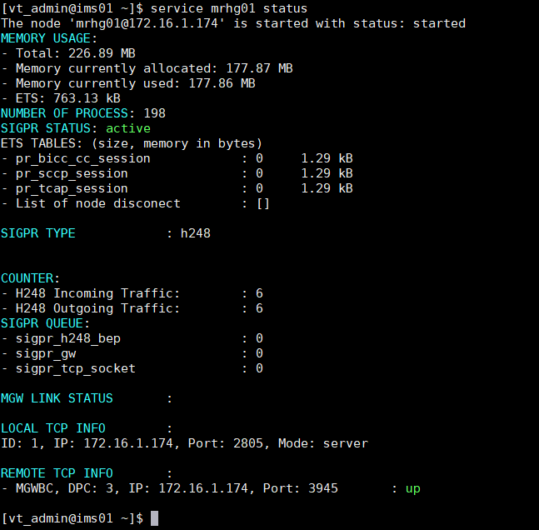

Đường dẫn:

1. Modul LOGIC

1.1. IMS CORE

Cai dat: /u01/ims/imscore/logic

Log: /u01/ims/imscore/logs

Binary: /u01/ims/imscore/logic/bin

1.2 SBC

Cai dat: /u01/ims/sbc/sblg

Log: /u01/ims/sbc/log

Binary: /u01/ims/sbc/sblg/bin

1.3 MMTEL

Cai dat: /u01/ims/vims/vims_mmtel_logic/

Log: /u01/ims/vims/logs

Bin: /u01/ims/vims/vims_mmtel_logic/bin

1.4 MRF

Cai dat: /u01/ims/mrf/mrlg

Log: /u01/ims/mrf/mrlg/log

Bin: /u01/ims/mrf/mrlg/bin

2. Modul diameter

Cai dat:

SBC: /u01/ims/sbc/sbdia

IMSCORE: /u01/ims/imscore/diagw

MMTEL: /u01/ims/vims/diagw

Log:

Sbc: /u01/ims/sbc/log

Imscore: /u01/ims/imscore/logs

Mmtel: /u01/ims/vims/logs

Bin:

SBC: /u01/ims/sbc/sbdia/bin

IMSCORE: /u01/ims/imscore/diagw/bin

MMTEL: /u01/ims/vims/diagw/bin

3. Modul ENUM/DNS

Cài đặt:

IMSCORE, MMTEL: /u01/ims/imscore/dnsgw/

SBC: /u01/ims/sbc/sbdns

Log:

IMSCORE, MMTEL: /u01/ims/imscore/logs

SBC: /u01/ims/sbc/log

Binary:

IMSCORE, MMTEL: /u01/ims/imscore/dnsgw/bin

SBC: /u01/ims/sbc/sbdns/bin

4. Modul H.248

Cài đặt:

MRF: /u01/ims/mrf/mrhg

SBC: /u01/ims/sbc/sbhg

Log:

MRF: /u01/ims/mrf/mrhg/log

SBC: /u01/ims/sbc/sbhg/log

Binary:

MRF: /u01/ims/mrf/mrhg/bin

SBC: /u01/ims/sbc/sbhg/bin

5. Modul SipGW

Cài đặt: /u01/ims/sipgw

Log: /u01/ims/sipgw/log

Binary: /u01/ims/sipgw/bin

Service sblg01 remote_console

Ets: info()

6. database

IMS, MMTEL:

Cài đặt: /u01/ims/imscore/dbgw

Log: /u01/ims/imscore/logs

Binary: /u01/ims/imscore/dbgw/bin

SBC:

Cài đặt: /u01/ims/sbc/sbdb

Log: /u01/ims/sbc/log

Binary: /u01/ims/sbc/sbdb/bin

7.MGW

Cài đặt: /u01/ims/vims/mgw

Log: /u01/ims/vims/mgw/logs

Binary: /u01/ims/vims/mgw/bin

8. vCCF 1

Cài đặt: /u01/ims/vims/ccf

Log: /u01/ims/vims/ccf/logs

Binary: /u01/ims/vims/ccf/bin

9. OAM

OAM1:

Cài đặt: /u01/ims/vims/oam

Log: /u01/ims/vims/oam/log

Bianry: /u01/ims/vims/oam/bin

Ha_framework1:

Cài đặt: /u01/ims/vims/ha_framework

Log: /u01/ims/vims/ha_framework/log

Bianry: /u01/ims/vims/ha_framework/bin

Mysql:

Cài đặt: /u01/ims/mysql

Log: /u01/ims/mysql/data

Binary: /u01/ims/mysql/bin

**Confd:**

Cài đặt: /opt/confd/current

Log: /opt/confd/current/var/confd/log

Binary: /opt/confd/current/bin

**EMS_AGENT@172.16.1.174:**

Cài đặt: /u01/ims/vims/ems_agent

Log: /u01/ims/vims/ems_agent/log

Binary: /u01/ims/vims/ems_agent/bin

**STATUS SIPGW**

II. GIÁM SÁT HỆ THỐNG EMS

III. Cauas hinh qua CLI

**Init mode:**

Config

Ext-config

Exit

Show

**Extern-config**

Backup confd name backup_oam

Changepwd

changuerpwd

Dis, enable; [csdia01@172.16.1.174](mailto:csdia01@172.16.1.174) cs_dia44

Exit

Get

No: subcri, alarm, alarm_severity, SS

alarm :delete alarm

alarm_severity :no alarm_severity

alarm_user_mapping :alarm user mapping sms

ftpserver :ftp server

subcriber :Delete user subcribe on system

user :delete user from IMS system

pushCDR

restart

restore

alarm :get alarm information

alarm_severity :add/mod alarm severity

alarm_user_mapping :alarm user mapping sms

ftpserver :ftp server

user :add/mod user into IMS system

show

alarm :get alarm information

alarm_current :get alarm information log

alarm_history :get alarm history

alarm_severity :show severity

alarm_terminated :Get alarm terminated

alarm_user_mapping :alarm user mapping sms

confd-backup-dir :Netconfig Backup Directories

ftpserver :ftp server

history :Command history

kpi :show kpi value

permission :User permission of IMS system

user :get information user in IMS system

start

ethcard :start ethcard server :get server status

stop

ethcard :start ethcard server :get server status